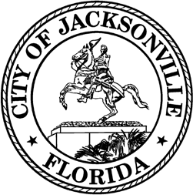

**OFFICE OF THE CITY COUNCIL**

|  |  |
| --- | --- |
| COUNCIL MEMBER JIMMY PELUSO  DISTRICT 7  OFFICE (904) 255- 5207  FAX (904) 255-5230 | SUITE 425, CITY HALL  117 WEST DUVAL STREET JACKSONVILLE, FL 32202  E-MAIL: [JPELUSO@COJ.NET](mailto:JPELUSO@COJ.NET) |

**MEETING NOTICE**

Notice is hereby given that Council Member Jimmy Peluso will host a noticed meeting on September 3, 2025, at 11:30 a.m., in the Lynwood Roberts Room on the first floor of City Hall at 117 West Duval Street, Jacksonville, FL 32210 to discuss the roadway resurfacing list and other matters. This meeting is open to the public and all interested parties are welcome.

For additional information, please contact Brooks Dame at [bdame@coj.net](mailto:bdame@coj.net) or (904) 255-5135.

Accommodation Requests:

Pursuant to the American with Disabilities Act, accommodations for persons with disabilities are available upon request. Please allow 1-2 business days for a notification to process; last- minute requests will be accepted but may not be possible to fulfill. Please contact Disabled Services Division at: VM (904) 255-5466, TTY (904) 255-5475, or email your request to [KaraT@coj.net.](mailto:KaraT@coj.net)

JP/bd

NOTICED ON: August 29, 2023, at 2:30 p.m., pursuant to 15.103(c), Ordinance Code.

cc: Council Members and Staff

Jason Teal, Director/Council Secretary   
Bernadette Smith, Chief, Legislative Services Division Teresa Eichner, Chief, Public Information Division Yvonne Mitchell, Chief, Administrative Services Division  
Colleen Hampsey, Chief, Research Division [CITYC@COJ.NET](mailto:CITYC@COJ.NET)

Electronic Notice Kiosk – 1st Floor City Hall Public Notice System – City Council Web Page Media Box

File Copy